C. V

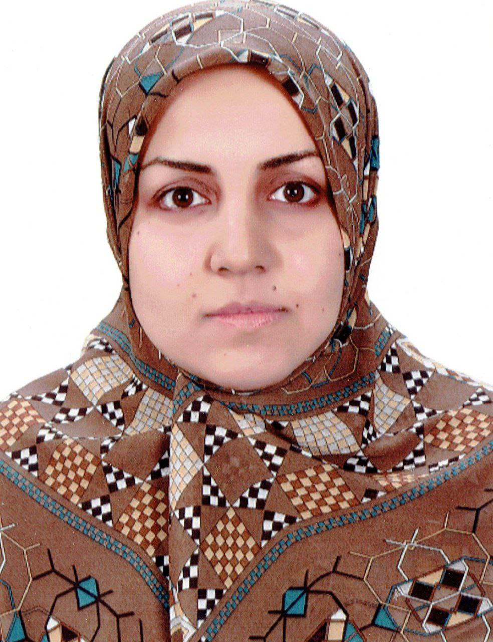
Photo

Name: hulal saleh sahib
Date of Birth: 24/12/1980
Religion: muslim
Martial statues: married
Specialization: medicine / pediatrics
Scientific Degree: professor
Work Address: college of dentistry
E-mail: hulal.sahib@qu.edu.iq

Scientific Certification:

Date | College | University | Degree science
2004 | Medical college | AL-Qadissyah university | M.B.CH.B.
2012 | AL-Kufa medical college | AL-Kufa university | F.I.B.M.S pediatrics
Date | Scientific Title | No.
2012 | Lecturer
2016 | Ass.Prof
2022 | Prof

Courses Which You Teach:
Year | Subject | Department | No.
2012-2017 | pediatrics | Pediatrics
2018-now | embryology | Conservative therapy

Conferences which you participated:
Type of Participation | Place | Year | Conferences Title | No.  ( بحث / بوستر حضور)
lecturer | College of medicine | 2018 | The first international scientific conference for medical sciences | 1
Attendance | Dubai | 2018 | 3rd convention of the importance of herbal medicines and dietary supplements | 2
lecturer | College of medicine | 2019 | The second international scientific conference for medical sciences | 3
Attendance | Thi qar university | 2020 | First international virtual medical conference | 4
attendance | Al-qadissyah university | 2020 | First international virtual scientific conferenc | 5

Researches

- ELISA test for toxoplasmosis on cord blood of newborns at AL-Najaf province-2012
- The impacts of maternal diabetes on newborns admitted to NICU of maternity and children teaching hospital in Al-Diwaniya city
- Determinants of outcome in newborn with HIE at AL-Diwaniya maternity and children teaching hospital
- Risk factors of perinatal asphyxia; a study at Al-DIWANIYA maternity and children teaching hospital
- Salmonella hepatitis as a typical presentation of typhoid fever, its impacts and prognosis
- Adenoid hypertrophy among school aged Iraqi children, the effects of severity and duration on its co-morbidities
- Nutritional status among children with congenital heart disease at al-Diwaniya province
- Antimicrobial resistance modes in children with pyelonephritis at AL-Diwaniya city, Iraq
- The burden of obesity on children health, its impact and complication

