Lecture 20 General pathology Dr. Ali H. Murad
Respiratory System Disorders
can be differentiated into two groups based on the nature of their symptoms: acute and chronic disease.
Acute respiratory infections include sinusitis, the common cold, rhinitis, epiglottitis, laryngitis, etc. Chronic respiratory diseases include lung cancer, COPD (chronic obstructive pulmonary disease), sleep apnea, cystic fibrosis, and occupational lung diseases.
Some of the major respiratory disorders are as follows: asthma, chronic obstructive pulmonary disease (COPD), emphysema, chronic bronchitis, and mesothelioma.
Asthma
is a chronic respiratory disease that affects the lungs and airways, making it difficult to breathe. During an asthma attack, airway narrows, the muscles surrounding it tighten, and the lungs fill with mucus. There is no cure for asthma, but the patient can live a long and healthy life with proper treatment.
causes:
- Allergic: Some people’s allergies can cause an asthma attack. Allergens include things like molds, pollens and pet dander.
- Non-allergic: Outside factors can cause asthma to flare up. Exercise, stress, illness and weather may cause a flare.
signs and symptoms
- Chest tightness, pain or pressure.
- Coughing (especially at night).
- Shortness of breath.
- Wheezing.
Treatment:
- Bronchodilators
- Anti-inflammatory medicines

Chronic Obstructive Pulmonary Disease (COPD)
Emphysema
is a lung condition that causes shortness of breath. In people with emphysema, the air sacs in the lungs (alveoli) are damaged. Over time, the inner walls of the air sacs weaken and rupture — creating larger air spaces instead of many small ones. This reduces the surface area of the lungs and, in turn, the amount of oxygen that reaches your bloodstream.
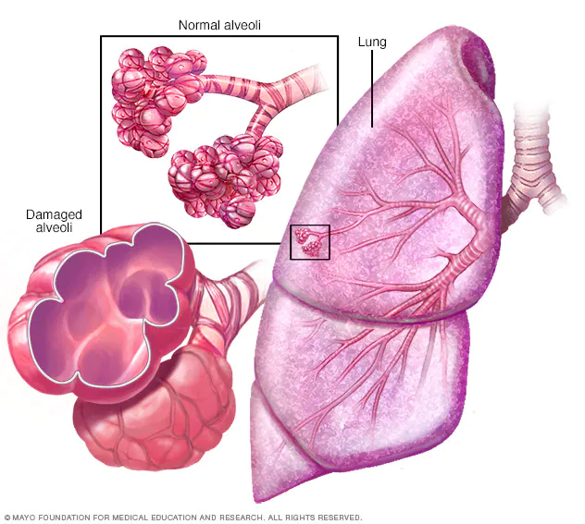

Symptoms:
No signs or symptoms for many years. The main symptom of emphysema is shortness of breath, which usually begins gradually.
patients may start avoiding activities that cause short of breath, so the symptom doesn't become a problem until it starts interfering with daily tasks. Emphysema eventually causes shortness of breath even while you're at rest.
Causes:
The main cause of emphysema is long-term exposure to airborne irritants, including:
- Tobacco smoke
- Marijuana smoke
- Air pollution
- Chemical fumes and dust
Rarely, emphysema is caused by an inherited deficiency of a protein that protects the elastic structures in the lungs. It's called alpha-1-antitrypsin deficiency emphysema.
Complications:
People who have emphysema are also more likely to develop:
- Collapsed lung (pneumothorax). A collapsed lung can be life-threatening in people who have severe emphysema, because the function of their lungs is already so compromised.
- Heart problems. Emphysema can increase the pressure in the arteries that connect the heart and lungs. This can cause a condition called cor pulmonale, in which a section of the heart expands and weakens.
- Large holes in the lungs (bullae). Some people with emphysema develop empty spaces in the lungs called bullae. They can be as large as half the lung. In addition to reducing the amount of space available for the lung to expand, giant bullae can increase your risk of pneumothorax.
Chronic Bronchitis
Chronic Bronchitis refers to the long-term inflammation of the bronchi in the respiratory tract that causes the airways to fill with mucus.
Symptoms:
Chronic bronchitis fills the airways with thick mucus. The small hairs that normally move phlegm out of the lungs are damaged. That makes cough. As the disease goes on, it’s harder for patients to breathe.
Other signs of chronic bronchitis may include:
- Cough, often with mucus
- Wheezing
- Tight chest
- Shortness of breath
- Feeling tired
The symptoms may be worst in the winter, when humidity and temperatures drop.
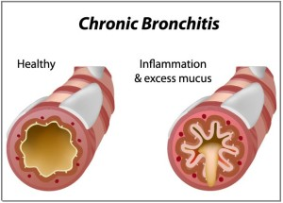

Causes:
Cigarette smoking is by far the No. 1 cause of chronic bronchitis. More than 90% of people with the disease smoke or used to smoke. Other things that raise the chances include:
- Secondhand smoke
- Dust
- Certain fumes, like hairspray if work in a hair salon or house paint
- Air pollution, welding fumes, engine exhaust
- Coal, fire smoke
Chronic bronchitis may make it easier to catch respiratory infections like colds, the flu, and pneumonia.
Treatments:
- Bronchodilators
- Anti-inflammatory drugs
- Oxygen therapy
- Specialized rehab program
Bronchiectasis
is a long-term condition where the airways of the lungs become widened, leading to a build-up of excess mucus that can make the lungs more vulnerable to infection.
The two primary symptoms are a cough and daily production of mucus (sputum). Other symptoms typically include: Coughing up yellow or green mucus daily. Shortness of breath that gets worse during flare-ups. persistent cough that usually brings up phlegm (sputum) shortness of breath.
Risk factors:
- Severe pneumonia.
- Whooping cough or measles
- Tuberculosis.
- Fungal infections.
Complications:
include pneumonia, lung abscess, empyema, septicemia, , respiratory failure, secondary amyloidosis with nephrotic syndrome, and recurrent pleurisy

Treatment:
Antibiotics are the most common treatment for bronchiectasis. Oral antibiotics are suggested for most cases, but harder to treat infections may require intravenous (IV) antibiotics
What is the difference between bronchitis and bronchiectasis?
Bronchiectasis is a permanent widening and scarring of the airways of the lungs, often due to repeated or severe infections. Bronchitis is inflammation of the large and small airways of the lungs. Acute bronchitis is often due to a viral infection
Mesothelioma
Is a form of cancer that affects the mesothelium, the membrane that lines chest cavity. Usually by the time the disease is identified, it has become so advanced that the 5-year survival rate hovers somewhere between 5 and 10 percent.
It is caused by the inhalation of asbestos fibres, a type of mineral that was widely used in a variety of building materials .
Symptoms of mesothelioma include severe chest pain, weight loss, fatigue, fever, and shortness of breath.
Chest pain may be caused by the spread of the disease to involve the pleura, the membrane that envelop the lungs. Severe, intractable pain caused by such conditions may require surgery to cut the nerves that supply the affected segment.

