كليه طب الاسنان جامعه القادسية
University of alQadisiya MEDICAL PHYSICS collage of Dentistry Lec LUMA HAFED
Laser in medicine
Lec luma hafed

[MEDICAL PHYSICS]

Laser in medicine
A laser is a device that emits light through a process of optical amplification based on the stimulated emission of electromagnetic radiation.
is abbreviation of Light Amplification By Stimulated Emission of Radiation.
The first laser was built in 1960 by Theodore H. Maiman at Hughes Research Laboratories, based on theoretical work by Charles Hard Townes and Arthur Leonard Schawlow.
Properties of Laser
- narrow beam of light (focus).
- single wavelength (monochromatic).
- High Intensity
- each wave is in phase (coherent) with other near it.
حيث يكون لأشعة الليزر صفات متماثلة من حيث الطور والاتجاه والطاقة
Basic theory for laser
If an incident photon is energetic enough, it may be absorbed by an atom, raising the latter to an excited state. It was pointed out by Einstein in 1917 that an excited atom can be revert to a lowest state via two distinctive mechanisms:
- Absorption:
- Spontaneous Emission and
- Stimulated Emission

Absorption:
Let us consider an atom that is initially in level 1 and interacts with an electromagnetic wave of frequency n. The atom may now undergo a transition to level 2, absorbing the required energy from the incident radiation. This is well-known phenomenon of absorption.
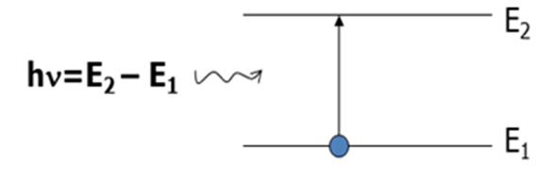
Absorption

Spontaneous emission:
Each electron can drop back spontaneously to the ground state emitting photons. Emitted photons bear no incoherent. It varies in phase from point to point and from moment to moment. e.g. emission from tungsten lamp.
To generate laser beam three processes must be satisfied:-
1. Population inversion.
2. Stimulated emission.
3. Pumping source.
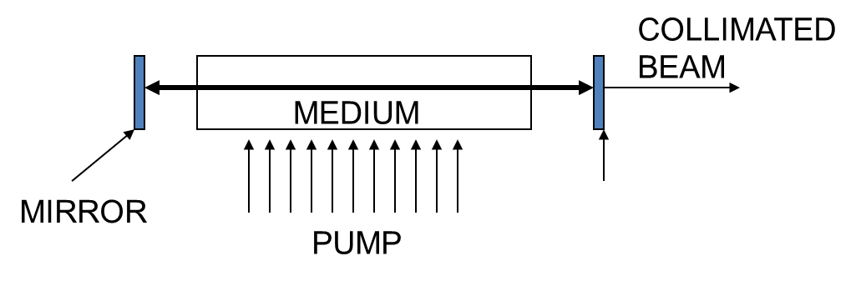
1.Population inversion
Generally electrons tends to (ground state). What would happen if a substantial percentage of atoms could somehow be excited into an upper state leaving the lower state all empty? This is known as a population inversion.
2.Stimulated emission:
An incident of photon of proper frequency could then trigger an avalanche of stimulated photon- all in phase (Laser).
Consider a gas enclosed in a vessel containing free atoms having a number of energy levels, at least one of which is Metastable. By shining white light into this gas many atoms can be raised, through resonance, from the ground state to excited states, and the population inversion condition is satisfied.
• E1 = Ground state,
• E2 = Excited state (short life time ns),
• E3 = Metastable state (long life time from ms to s).
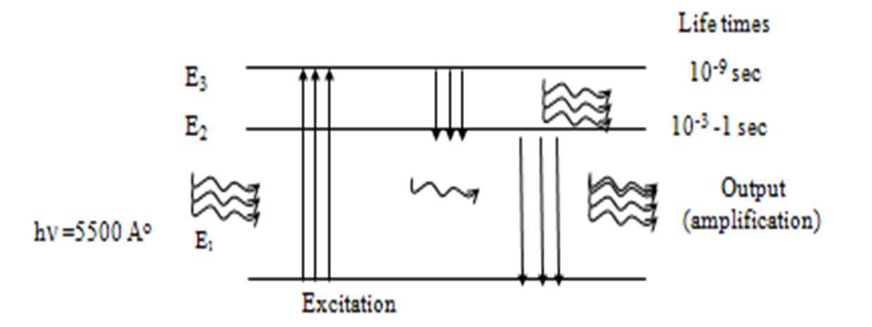
Each electron is triggered into emission by the presence of electromagnetic radiation of the proper frequency. This is known as stimulated emission and it is a key to the operation of laser. e.g. emission from Laser
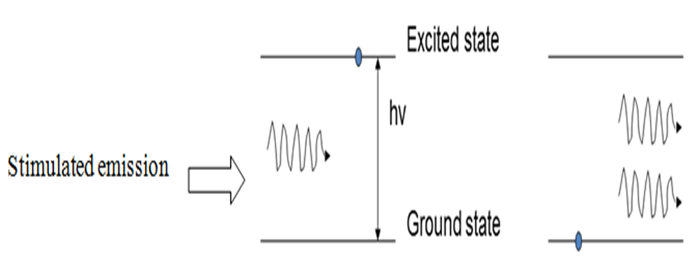

3.Pumping Sources
  - Optical Pumping: Suitable For Liquid And Solid Laser Because They Have Wide Absorption Bands.
  - Electric Pumping: Suitable For Gas Laser Because They Have Narrow Absorption Band.
  - Chemical Reaction.

Types of lasers
- According to the active material: solid-state, liquid, gas, excimer or semiconductor lasers.
- According to the wavelength: Infra-red (IR), Visible, Ultra-violet (UV) or X-ray Lasers.
1- Solid-state lasers have lasing material distributed in a solid matrix (such as ruby or Nd-YAG). Flash lamps are the most common power source. The Nd-YAG laser emits infrared light at 1.064 nm.
2- Semiconductor lasers, sometimes called diode lasers, are p-n junctions. Current is the pump source. Applications: laser printers or CD players.
3- Gas lasers are pumped by current. Helium- Neon (He-Ne) lasers in the visible and IR. Argon lasers in the visible and UV. CO2 lasers emit light in the far-infrared (10.6 mm), and are used for cutting hard materials.
4- Excimer lasers: use reactive gases, such as chlorine and fluorine, mixed with inert gases such as argon, krypton, or xenon. Excimers laser in the UV.
Laser application in medicine
Laser treatment. Laser for cancer treatment. Laser removal of kidney stones. Laser removal of parts of the prostate. Laser cleaning of blood vessels for eye problems. Cosmetic laser uses Laser to remove birthmarks Laser to grow hair Laser hair removal Laser (hair) Other cosmetic uses Laser in dentistry. Laser treatment of hemorrhoids
بالليزر العلاج بالليزر .علاج السرطان بالليزر . إزالة حصوات الكلى بالليزر . استئصال أجزاء من البروستات بالليزر . تنظيف الشرايين الليزرلمعالجه العيون . استخدمات الليزر التجميلية الليزر( لإزالة الوحمات الليزر, لإنبات الشعر, ازالة الشعر بالليزر ليزر (الشعر) استخدامات تجميلية أخرى ). الليزر في طب الأسنان . علاج البواسير بالليزر
Laser Teeth whitening
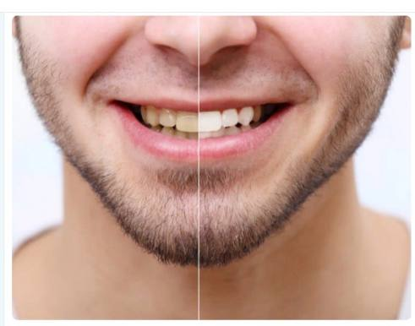
also known as strong whitening it is another type of teeth whitening system that the dentist can provide. The whitening product is placed on the teeth and then laser light is shined on them to activate the whitening
تبييض الأسنان بالليزر المعروف أيضاً باسم التبييض القوي، وهو نوع آخر من أنظمة تبييض الأسنان اضافه الى التبيض العادي بالجل التي يمكن أن يوفرها طبيب الأسنان، إذ يوضع منتج التبييض على الأسنان ثم يُسلّط عليها ضوء الليزر لتنشيط التبييض، ويستغرق التبييض بالليزر نحو ساعة.
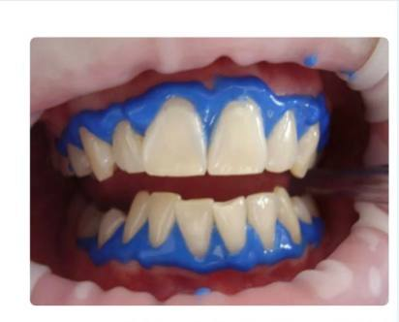
Advantages of laser whitening.
- One of the fastest ways to get noticeably whiter teeth.
- Effects should appear within a few hours after the first appointment.
- Removes tough stains that other whitening treatments may not be able to remove.
- Some types of laser teeth whitening treatments can be used to lighten just one tooth or a few severely stained teeth.
- Laser teeth whitening is an easy, non-invasive procedure.
- The results of laser whitening can last for a long time
مميزات التبييض بالليزر .
- من أسرع الطرق للحصول على أسنان ناصعة البياض بشكل ملحوظ.
- تظهر تأثيرات التبيض في غضون ساعات قليلة بعد الموعد الأول.
- يزيل البقع الصعبة التي قد لا تتمكن علاجات التبييض الأخرى من إزالتها.
- يمكن استخدام بعض أنواع علاجات تبييض الأسنان بالليزر لتفتيح سن واحدة فقط أو بضع أسنان شديدة التبقع .
- يعد تبييض الأسنان بالليزر إجراءً سهلاً وغير جراحى.
- يمكن أن تستمر نتائج التبييض بالليزر لفترة طويلة.

