Light in Medicine

The sun is the major source of the light in the world, the spectrum of light is shown in fig. (1-a). The UV and IR light is invisible to the human eye, but can none the less have dangerous effects. The visible light in the wavelength(400-700)nm, that provides us with color vision represents just a small, part of the electromagnetic spectrum. as shown in fig.(1-b).
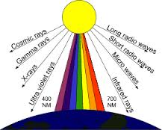
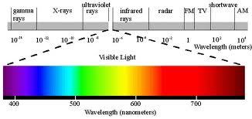

(a)
(b)
Fig.(1): shows electromagnetic spectrum

Properties of Light:--
- Waves, particle and electromagnetic spectrum.
- Transverse waves.
- Interact with matter.
- Absorption:- The absorption of light cause:-
  - Chemical changes:- For example:- when light photon absorbed in eye (cones and rods)retina the chemical reaction is occur which case action potential, the latest cause electrical signal to brain.
  - Heat generation:- For example IR used in medicine to heat tissue and Laser beam used to weld and coagulate small blood vessel in the retina.
  - Fluorescence:- absorption of light may emits a lower energy light photons, for example (light bulb). The amount of the Fluorescence and the color depend on the wavelength of the light and the chemical composition of the material. In medicine fluorescence is used to detection of porphyria.
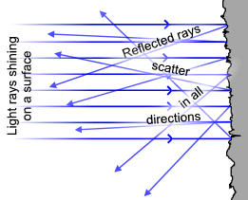
- Reflection:-This property useful to see image in mirror, there two types of reflection:

  - Diffuse reflection: Is the reflection of light from a surface such that an incident ray is reflected at many angles, i.e., rough surface and many directions.

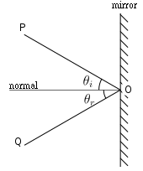
  - Specular reflection: Is the mirror-like reflection of light (or of other kinds of wave) from a surface, in which light from a single incoming direction (a ray) is reflected into a single outgoing direction, i.e., shiny surface and one direction.

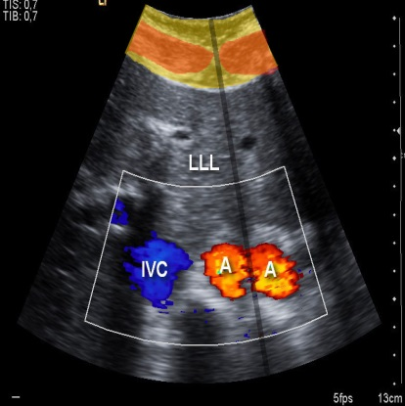
- Refraction:- Is the change in direction of propagation of a wave due to a change in its transmission medium. The speed of light change when it goes from one medium to other, the ratio of speed of light in vacuum to speed of light in medium known as refractive index(n).This property permits light to be focused and is the reason we can read and see objects. Double aorta artefact in sonography due to difference in velocity of sound in muscle and fat as illustrated in adjacent figure.
- Scattering.
- Diffraction and polarization.

Measurement of the light and its units
There are three general categories of light [UV, Visible and IR] are defined as the terms of wavelengths (λ) [micrometer, nanometer or angstrom)
- UV:- 100-400 nm.
- Visible :- 400-700 nm.
- IR :- 700-10,000 nm.

The units of light divided to
- Radiometric units: Is the measurement of optical radiation including visible light (UV, VIS, and IR).
  - Irradiance: quantity of light (power) striking a surface it's measured in Watt per steradian per meter-square (W/sr.m²).
  - Radiance: intensity of a light source it's measured in Watt per square-meter (W/m²).
- Photometric units: Is the measurement of visible light only.
  - Illuminance: quantity of light (power) striking a surface it is measured in lumen per meter-square (lux = lm/m²).
  - Luminance: intensity of a light source it's measured in lumen per steradian per meter-square (lm/sr.m² = cd/m²).

Application of Visible light in medicine:-
- Visual information about patient, for ex: skin color and the abnormal structure in the body.
  - Mirror :- ophthalmoscope, otoscope.
  - Endoscope:- it is define as an instrument used for viewing internal body cavities. Endoscope classified in general in to two type:-
      - rigid endoscope:- consist of light source and lenses to magnification.
      - flexible endoscope:- which is used to obtain information from regions of the body that can not be examined with rigid endoscope, such as the small intestine and much of the large intestine, flexible endoscope have an opening that permits the physician to take samples of the tissue (biopsy) for microscopic examination.
There are other types of endoscope :-
    - Cystoscope for bladder
    - Proctoscope for rectum
    - Bronchoscope for air passages to lungs
    - Flexible endoscope for stomach : fiberoptic technique
    - Biopsy channel
    - Cold-light endoscope: very little IR radiation to minimize heating effect
- Transillumination:- It is clinically used to detection of:-
  - Hydrocephalus (water head):- the skull of infant is not fully calcified, light is able to penetrate the skull, an excess CSF in the skull, light will scattered to different parts producing patterns characteristics of hydrocephalus.
  - Collapsed lung in infants:- The bright light penetrate the thin front chest wall and reflects off the back chest wall to indicate the degree of collapsed lung. The physician can insert a needle into the area of collapse to remove the air between the lung and chest wall.
- Therapeutic uses :- The visible light has an important therapeutic use such as Jaundice , the most premature infants recover from Jaundice if their bodies exposed to visible light (usually blue light ~ 450 nm)

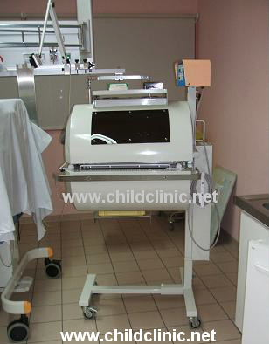

UV rays
UV photons have energy greater than visible light, it is more scattered than visible light because of its wavelength and it's more useful than IR. UV can't seen by the eye because it is absorbed before its reach to retina , its subdivided is :-
- UV_{C}=100-290nm.
- UV_{B}=290-320nm.
- UV_{A}=320-400nm.
Ultraviolet light can damage the eyes in several ways. Excessive exposure to the lowest wavelengths of UV light, also called UV_{C} , can cause damage to the cornea as well as the lens. These wavelengths are not common in nature, since they are absorbed by the atmosphere, but are present in in some industrial environments, such as electric arch welding.

The mid UV wavelengths, also called UV_{B}, can cause damage to the lens as well as cause welders eye (feels like sand in the eye). Mid UV light is present both in sunlight and in some industrial environments. The high UV wavelengths, also called UV_{A},are present in all outdoor environments. Generallly, UV rays can be made artificially by passing an electric current through a gas or vapor, such as mercury vapor.Excessive exposure can cause fatigue or snow blindness.

Applications of UV Light in Medicine
- Energy of UV photon > visible photon
- UV_{C} germicidal (kill germs) sterilize medical instruments:- Ultraviolet waves are effective in killing bacteria and viruses. Hospitals use germicidal lamps that produce these waves to sterilize equipment, water and air in operating rooms. It is also used to treat acne and psoriasis.
- Solar UV_{B} conversion of molecular products in the skin to vitamin D
- May improve certain skin conditions
- Half of the UV light hitting the skin from the sun and the other half scattered from the air in the other parts in the sky. thus effect melanin to cause tanning or sunburn.
- Solar UV light major cause of skin cancer. UV waves injure cells in the epidermis (outer layer) by diffusing into the inner layer and causing an enlargement of vessels. Blisters can occur due to too much exposure. If there is overexposure, blisters can leave scars or can cause skin cancer.

IR rays:-
IR photons have energy lower than visible light. Most of the thermal radiation emitted by objects near room temperature is infrared. Slightly more than half of the total energy from the Sun was eventually found to arrive on Earth in the form of infrared.
Infrared radiation is used in industrial, scientific, and medical applications. Night-vision devices using active near-infrared illumination allow people or animals to be observed without the observer being detected. Infrared thermal-imaging cameras are used to detect heat loss in insulated systems, to observe changing blood flow in the skin. It's divided into 3 regions:-
- IR_{A}:- 760-1400nm, it is most penetrating radiation.
- IR_{B}:- 1400nm-3μm, penetrating only slightly into tissue (it is heavily absorbed by water).
- IR_{C}:- 3-1000μm, does not penetrate the eye or skin.

Applications of IR radiation
- The warm we feel from the sun is mainly due to IR component.
- Night vision.
- IR can cause burn in the retina:-looking at the sun through the filter (e.g plastic sunglasses) remove most of the visible light and allows most of IR rays through can cause a burn on the retina. For safety use dark glasses to absorbs varying amount of IR & UV light from the sun.
- Physical therapy purpose:- IR able to heat deep tissues because of its penetrating. For example, heat lamps that produce a large percentage of IR (1000-2000nm) used to heat tissues.
- IR-photography:- there are two types:
  - Reflective IR-photography:-which use wavelength (700-900nm which called near-IR, penetrate the skin in the depth of 3mm) to show the pattern of veins just below the skin.
  - Emissive IR-photography:- it is usually called (Thermography),Infrared radiation can be used to remotely determine the temperature of objects (if the emissivity is known).

