**MY RESEARCH**

* >Detection of the Antibacterial Activity of Bioactive Peptide Isolated from Fermented Buffalo Milk in vitro.
* >Partial Purification and Characterization of Bioactive Peptides Extracted from Fermented Buffalo Milk
* *>In vivo antibacterial activity of whey protein derived from fermented milk of Iraqi buffalo*
* *>* Occurrence of Aerobic Bacteria in Sheep with Respiratory tract infection in Al-Diwaniyia Province
* *>* In vitro detection of the antimicrobial activity of ricinus communis leaves versus enterobacter aerogenes isolated from pneumonia cases of calves in al-diwaniyah / Iraq
* *>* Molecular characterization of enterohemorrhagic E. coli O157 and O153 isolated from tissue camel and human stool samples in Al-Diwaniyah, Iraq

**CONTACT ME**

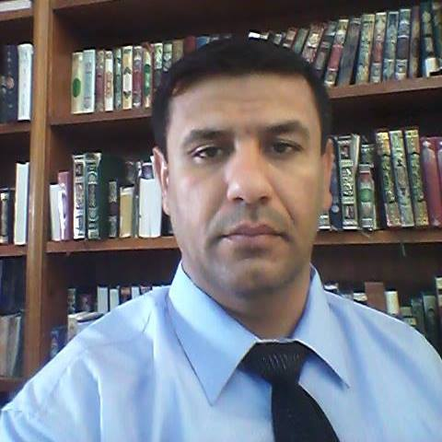

**MOSHTAQ TALIP HUSSEIN**

**lecturer Al-Qadisiyah University**  
 I head of basic science department of Dentistry college and chief of microbiology team in microbiology Lab.

Microbiology technologist test analyse microscopic bacteria, fungi, virus, working for hospital and medical Labs

I have skill in molecular biology.

analytical thinking skills

examination on specimens and all other microscopic life worms as well as microscopic organisms

PhD University of Babylon 2013-2016

McS University of Al-Qadisiyah 1999 – 2011  
  
 Bachelor Vet. Med. College 1999 – 2004  
  
Afak school 1994 –1999

Moshtaq.hussein@qu.edu.iq

009647812403390

Afak, AlDiwaniyah province, iraq

<https://www.facebook.com/moshtaq.talip/>

I have been working in University for 20 year , with my most recent experience being a Microbiologist at Lab. I posse valuable skill such as confidence and experience that I believe make me best suited for the position of Microbiology in your journals because of my skill being mentioned above

**SKILLS**

**Assist. Lecture Al-Qadisiyah university**  
Assistant Head of microbiology Department in Veterinary medicine college. I was leader of a research team in zoonotic and microbiology Las.

2018 - Present

2006 - 2018

**OBJECTIVE**

**CAREER**

**EDUCATION**