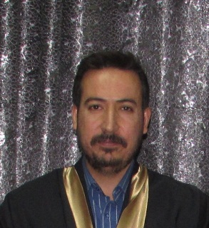
The name: Osama Mohammed Ghazi
Date of birth: 24/2/1974
Lecturer
Department of conservative therapy
Education:
- Ph.D. in oral and maxillofacial pathology from College of Dentistry/ Baghdad University 2019
- Master degree in oral and maxillofacial pathology from College of Dentistry/ Baghdad University 2014
- Bachelor in dental and oral surgery from College of Dentistry/ Baghdad University 1997
Scientific and administrative positions:
- Member of the Council of the Faculty of Dentistry university of Al-Qadisiyah
- Head of the Conservative therapy department since 2021
- Member of the Ministerial Committee to improve the quality of education for Iraqi dental colleges.
- Member of the examination committee at the Faculty of Dentistry, University of Al-Qadisiyah for four years.
- Member of the Scientific Committee in the department of Conservative therapy.
- Member of several permanent and temporary committees.
Research published in Scopus:
- The effect of IL-6 expression on the behavior of oral squamous cell carcinoma cells (an immunohistochemical study)
- Prognostic role of STAT-3 upregulation in oral squamous cell carcinoma
- Predictive value of cathepsin-d expression in oral squamous cell carcinoma
- Assessment of the psychological impact of dental aesthetics among undergraduate university students in Iraq.
- Frequency of central odontogenic tumors: a retrospective study in an Iraqi population utilizing 2022 WHO head and neck tumors classification.
Telephone number: 07824398218
Email: Osama.ghazi@qu.edu.iq

